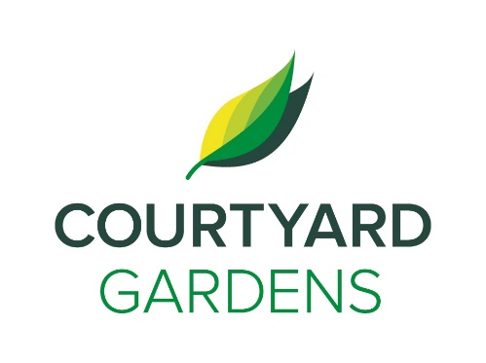

onnection

C

ourtyard

Assisted Living November 2019

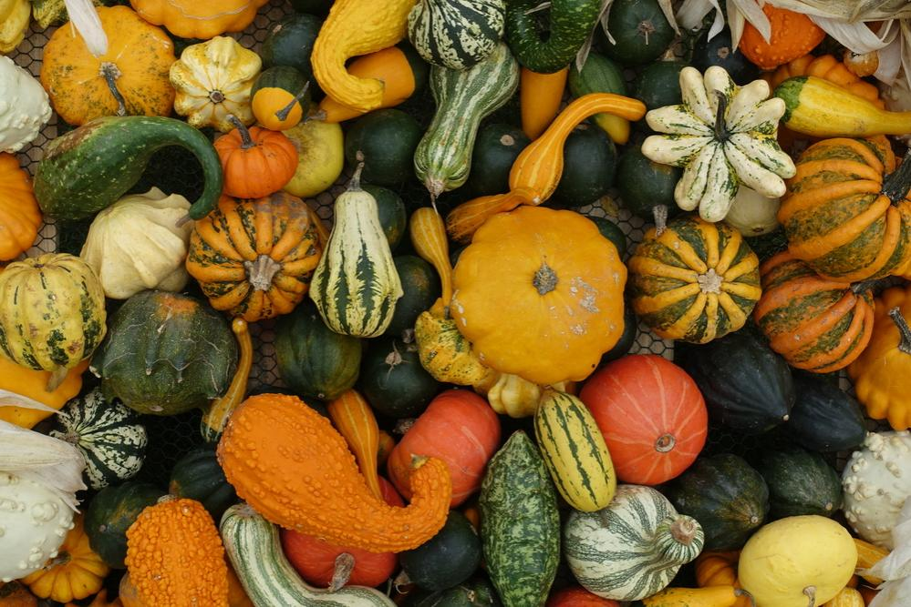

DINING DELIGHTS AT CYG

Living, Loving, Local Winter Squash!

When Going Out,

Be Sure to Always

Keep a List of Your

Medications with You!

**REMEMBRANCE DAY SERVICE**

**Richmond High School**

**Friday, November 8th**

**Ceremony 1: 9:30- 10:45 a.m.**

**Ceremony 2: 10:45- 12:00 p.m.**

Please let Charlene know if you have Service History

**Brunch Buffet!**

**November 10th**

**11:00 a.m. – 1:00 p.m.**

Join us, as we highlight & feature

our love for food

$19 per person

$9 for children (4-12 years-old)

Free for children 3 & under



***In Flanders Fields*** by John McCrae (Excerpt)

In Flanders fields the poppies blow  
Between the crosses, row on row,  
That mark our place; and in the sky the larks, still bravely singing, fly  
Scarce heard amid the guns below. We are the Dead. Short days ago, we lived, felt dawn, saw sunset glow,  
Loved and were loved, and now we lie in Flanders fields. be yours to hold it high.  
If ye break faith with us who die  
We shall not sleep, though poppies grow  
In Flanders fields.

* Armchair Travel to Scandinavian- Wendy’s Travel Adventure- **Saturday, November 2nd 2:00**
* Flu Shots- **Monday, November 4th 9:00 a.m. -12:00 p.m.**
* Richmond Singers Ensemble- **Wednesday, November 6th 2:00 p.m.**
* Resident Forum & Tea Social - **Thursday, November 7th 10:30 a.m.**
* Shopping Bus to Bridgeport Dollarama- **Thursday, November 7th 2:00 p.m.**
* Remembrance Day Event with Matthew Ma Performing- **Monday, November 11th 2:00 p.m.**
* Meet Me at the MoMa- **Wednesdays, November 13th & 27th 2:00 p.m.**
* Minoru Glee Club Performance- **Wednesday, November 20th 2:00 p.m.**
* Kurt von Hahn: Pianist Performing in the Lounge- **Friday, November 22nd 3:30 p.m.**
* Defy Gravity Dance Group Performance- **Sunday, November 24th 3:00 p.m.**
* Kerrisdale Senior Singers- **Tuesday, November 24th 3:00 p.m.**
* Happy Hour with Jennifer Lauren (FL)- **Friday, November 29th 3:30 p.m.**

**FLU SHOTS!**

**Monday, November 4th**

**9 a.m. – 12 p.m.**

**FEATURED LIFE ENRICHMENT EVENTS NOVEMBER**

*We invite you to visit and attend any of our featured dining events with friends and family.*

*Stay for a meal in our private dining room!*

***Make a reservation anytime!***

***604-273-1225***

**Guests:**

**Lunch $10.50**

**Dinner $14:50**