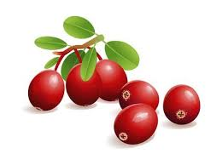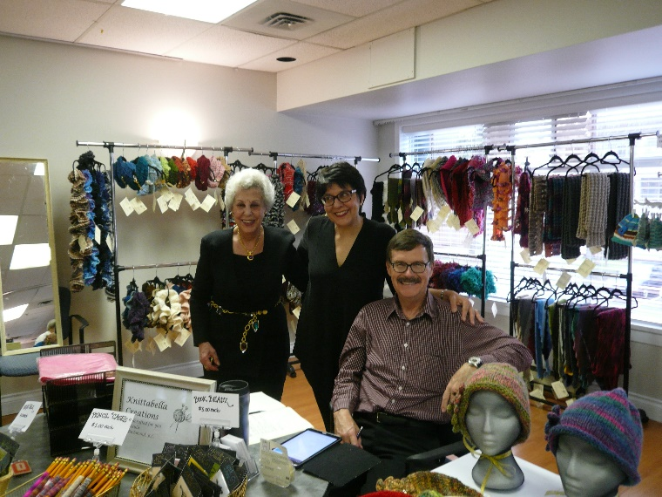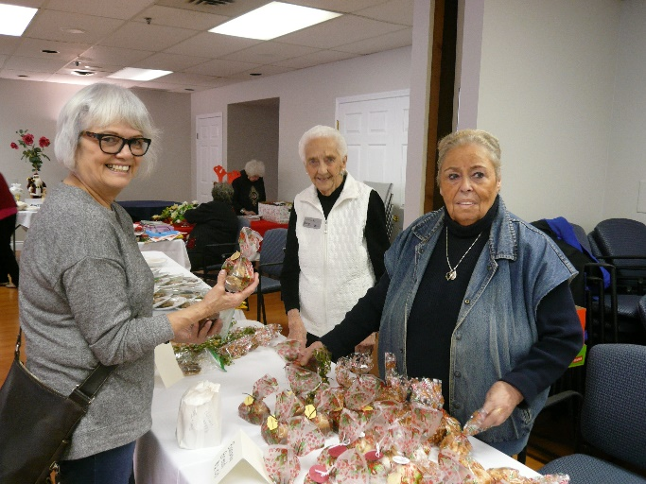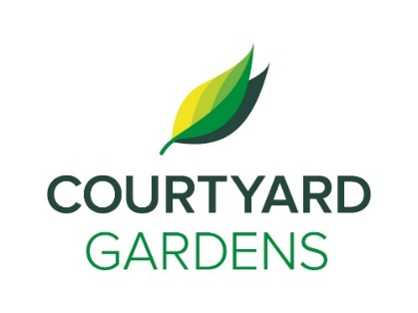

Living Loving Local: Cranberries

**FEATURED LIFE ENRICHMENT EVENTS IN DECEMBER**

* Holiday Market Place – **Monday, December 2nd 11:30 a.m.**
* Intergenerational Discussion w/ Research Student from Djavad Mowafaghian Centre for Brain Health – **Wednesday, December 4th 2:00 p.m.**
* Decorating Tree and Hot Chocolate Social on 2nd and 3rd Floor – **Saturday, December 7th 2:00 p.m.**
* Family Holiday Celebration with Langley Senior Ukulele Group – **Sunday, December 8th 2:00 p.m.**
* December Welcome & Birthday Tea – **Tuesday, December 10th 2:30 p.m. with the Soundscape Chorus**
* Christmas Bingo, Extra Prizes! **– Wednesday, December 11th 2:00 p.m.**
* Catholic Women’s Choir Performing – **Saturday, December 14th 1:30 p.m.**
* Youth Musicians and Artists Performing – **Sunday, December 15th 3:30 p.m.**
* Christmas Scavenger Hunt – **Monday, December 16th 2:00 p.m.**
* Sing-along with Brownies Group – **Tuesday, December 17th 6:45 p.m.**
* Happy Hour with Matthew Ma Performing – **Friday, December 20th 3:30 p.m.**
* Lighting of the Menorah – **Sunday, December 22nd 3:30 p.m.**
* Rowena Silver Bridson, Soprano & Victoria Smus, Pianist - **Monday, December 23rd 1:30 p.m.**
* Christmas Sing-along with Linda – **Tuesday, December 24th 2:00 p.m.**
* ‘Twas the Night Before Christmas Social – **Tuesday, December 24th 3:30 p.m.**
* New Year’s Eve Party with Colleen Durdon – **Tuesday, December 31st 2:30 p.m.**

Make Reservations for our Traditional Christmas Dinner at Reception!

Adult: $ 19.00

Children under 12: $ 9.00

Happy Holidays to all of you and your loved ones! This has been an action filled year here at Courtyard Gardens and 2020 is shaping up to be full and lively too. As we wrap up the year, I would like to say thank you for choosing Courtyard Gardens and for being part of this great place to live and to work. I would also like to say how much I appreciate the great team we have working here. They work to provide great service all year long. Early next year is Courtyard Gardens 30-year anniversary. We will be doing our big anniversary celebration in June of 2020. I hope you will get to enjoy some family time over the comings weeks and take part in some of the great seasonal programs in and around the building.

All the best of the season to all of you!

Amanda

Family Holiday Celebration

December 8th

2:00 p.m.

Ft. Langley

Ukulele Group

**Assisted Living/December 2019**

ourtyard

onnection

C

Happy Holidays &

Best Wishes in the New Year

**Thanks for Joining**

**us at the Holiday Market Place!**

**Success!**