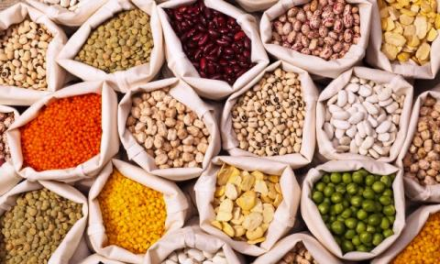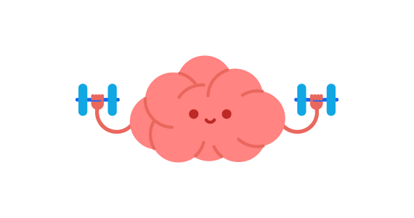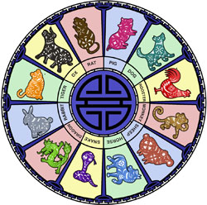

**New Life**

**Enrichment**

**Program!**

The Benefits of the Fit Minds Program:

* Improved ability to communicate with others
* Improved desire to engage
* Improved mood & reduction in anxiety
* Reduction in challenging behaviors
* Improved cognition
* Improved quality of life

The Chinese use a lunar calendar, which is based on the movement of

the moon!

**Robbie Burns Celebration!**

**Saturday, January 25th**

**4:00 p.m.**

**Dogwood Room**

**Bagpiper Addressing the Haggis**

Join us January 7th, 21st & 28th

at 3:00 p.m.!

* Resident Forum – **Thursday, January 3rd 2:00 p.m.**
* Fit Minds – **Tuesday, January 7th 3:00 p.m.**
* Happy Hour with Jennifer Lauren performing - **Friday, January 10th 3:00 p.m.**
* Carda Creations Clothing Sale – **Monday, January 13th 11:00 p.m.**
* Emergency Preparedness Presentation – **Monday, January 13th 2:00 p.m.**
* January Birthday & Welcome Tea with Elvis Presley Theme – **Tuesday,** **January 14th 2:30 p.m.**
* Happy Hour with Peter G Performing – **Friday January 17th 3:30 p.m.**
* Fit Minds – **Tuesday, January 21st 3:00 p.m.**
* Charades with Linda – **Monday, January 20th 2:00 p.m.**
* Lunch outing to Danny’s Chinese Restaurant – **Tuesday, January 21st 12:00 p.m.**
* Armchair Travel to Poland with Amanda – **Wednesday, January 22nd 2:00 p.m.**
* Addressing the Haggis with Piper John Ralston – **Saturday, January 25th 4:00 p.m.**
* Robbie Burns Dinner – **Saturday January 25th 4:45 p.m.**
* Chinese New Year Dinner **– Tuesday January 28th 4:45 p.m.**
* Ted Talks **– Tuesday, January 29th 2:00 p.m.**

**.**

-

**Beans & Lentils!**

Legumes are typically low in fat, contain no cholesterol, and are high in folate, potassium, iron and magnesium. They are a good source of protein. Legumes can be a healthysubstitute for meat, which has more fat and cholesterol.



Join us in celebration of the life and poetry of Robert Burns!Also, his contribution to Scottish culture.

His best-known work is Auld Lang Syne.

**FEATURED LIFE ENRICHMENT EVENTS IN JANUARY**

**Join us for a special dinner to celebrate the start of the ‘Year of the Rat’!**

**Tuesday, January 28th, 2020**

ourtyard

onnection

C

**Assisted Living/January 2020**