******** 

* Family Feud Game **– Wednesday, February 5th 3:30 p.m.**
* Lunch Outing to “The Deck” Restaurant – **Friday, February 7th 12:00 p.m.**
* Happy Hour with Allen Boolinoff Performing - **Friday, February 7th 3:30 p.m.**
* February Brunch – **Sunday, February 9th 11:00 a.m. – 1:00 p.m.**
* February Birthday & Welcome Tea w/ Peter Williams – **Tuesday, February 11th 2:30 p.m.**
* Health Talk: High Blood Pressure – **Thursday, February 13th 10:00 a.m.**
* Lache Cercel Trio Performing: Violinist, Guitar & Double Bass Player - **Friday, February 14th 2:00 – 3:00 p.m.**
* Youth Musicians & Artists Performing – **Sunday, February 16th 3:30 p.m.**
* Food Forum – **Thursday, February 20th 10:30 a.m.**
* Pacific Chamber Music Academy Students Performance - **Sunday, February 23rd 3:30 p.m.**
* Weekly Scrabble Game in 3rd Floor Lounge – **Tuesday,3:00 p.m.**

Reasons to love Lean Canadian Beef:

* Excellent source of high-quality protein for muscle repair!
* Packed with Vitamin B
* Zinc to support a strong immune system!
* One of the best sources

of iron!

Assisted LivingFebruary 2020**\\**

Living Loving Local Theme:

BEEF!

**Check out our new and improved bulletin board! The sign-up sheets are now located on a table opposite to the bulletin board.**

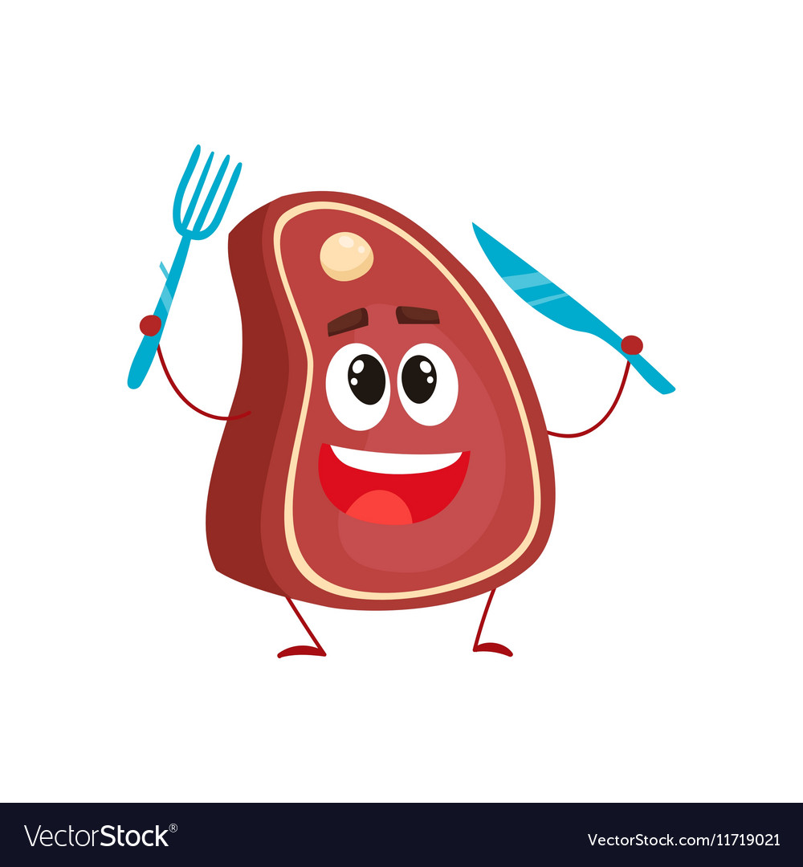

**Valentine’s Day Special Lunch**

**Friday, February 14th**

**11:45 a.m. – 1:00 p.m.**

**| Guests $14.50 |**

**Followed by** **Lache Cercel Trio Performance at 2 p.m.**



Join us for a February Brunch

Sunday, February 9th

11:00 a.m. – 1:00 p.m.

Kurt von Hahn

performing in the

Fireside Lounge

From 12 to 1pm

| Guests $19 |

Reservations can be made at the reception desk or by calling 604-273-1225

**FEATURED LIFE ENRICHMENT EVENTS IN FEBRUARY**

Topic: High Blood Pressure!

February is heart month, a time to bring attention to the importance of cardiovascular health.

Thursday, February 13th

10:00 a.m.

Dogwood Room

ourtyard

onnection

C