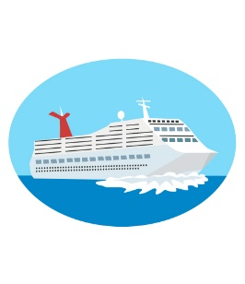

ourtyard

C

onnection

March 2020

Assisted Living

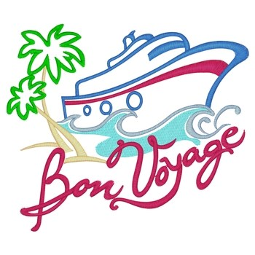

Jamaican Gala Dinner- Friday, March 6th

Fiesta Dinner- Tuesday, March 10th

Captain’s Lunch – Thursday, March 12th

**Friday, March 6th**

Happy Hour with “Tunemakers” – **3:30p.m.**

**Saturday, March 7th**

Weekend Trivia Challenge – **3:30p.m.**

**Sunday, March 8th**

Pianist, David Baron– **12:00** – **1:00p.m.**

**Monday, March 9th**

Music Bingo: Songs from the 40s, 50s & 60s – **2:00p.m.**

**Tuesday, March 10th**

Caribbean Party with Mariachi Trio – **2:30p.m.**

**Wednesday, March 11th**

Beach Volleyball– **3:30 p.m.**

**Thursday, March 12th**

Armchair Travel to Cuba- **3:00 p.m.**

**Friday, March 13th**

Cruise Week Trivia – **2:00p.m.**

Happy Hour with Patrick Roy Performing – **3:30p.m.**

CRUISE WEEK

*We invite you to visit and attend any of our featured dining events with friends and family. Stay for a meal in our private dining room!*

***Make a reservation anytime! 604-273-1225***

Special Cruise Week Meals

Join us, as we celebrate our love for **maple** throughout the month of March.

LIVING, LOVING, LOCAL |**Guests $15**|

Join us for an **Earthquake Preparedness Presentation** by the City of Richmond

Dogwood Room

Wednesday, March 4th 2:00p.m.

**FEATURED LIFE ENRICHMENT EVENTS IN MARCH**

* TAI CHI- modified weekly program – **Monday 1:00p.m.**
* Performance by Pianist, David Baron– **Sunday, March 8th 12:00p.m.**
* Youth Musicians & Artists Performing – **Sunday, March 8th 3:30p.m.**
* Health Talks – **Thursday, March 12th 10:00a.m.**
* St. Patrick’s Day Birthday & Welcome Tea – **Tuesday, March 17th 2:30p.m.**
* Lunch Outing: O’Hare’s Pub – **Friday, March 20th 12:00p.m.**
* Happy Hour with Martin Adcock – **Friday, March 20th 3:30p.m.**
* Happy Hour with Celtic Fiddler “Kierah” – **Friday, March 27th 3:30p.m.**
* Gilmore Church Ukulele Players – **Sunday, March 29th 3:00p.m.**



DINING DELIGHTS AT CYG