

ourtyard

C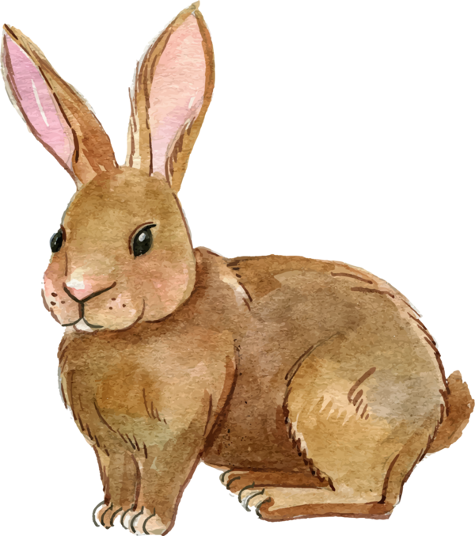

onnection

Assisted Living

September 2020



**Rabbits and more rabbits**

Did you know?

A female rabbit can deliver up to 60 new kits a year!

This is a friendly reminder to please not feed the rabbits. They become dependent on people for food and start making nests inside

our building

which is not safe

for them nor is it

good for us.

**Moving On…**

**Emily Berry**

**Eugenia Krupinski**

**Nonna Dudchenko**

**Corrie Van Der Graaf**

**Klementyna Solek**

**Marian Jensen**

**Warm Welcomes…**

**Cora Chua #223**

**Vera Panaioti #317**

**Eric & Beverly Drayton #210**

**Joan Downie #315**

**Eileen Robertson #230**

**Sandra Stern #112**

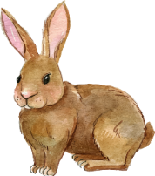

**Our Trio Bike Taxi has arrived!!**

It can hold up to two people, has a canopy to keep the sun/rain off and a motor so our staff don’t have to do all the work at the pedals! We hope you’re excited to feel the wind in your hair, the sun on your face and the wonderful feeling of riding a bike again while out enjoying the sights and sounds around you.

**Foot Care Nurse Services**

To Book an Appointment,

Call Pam at

(778) 861-8502

We will study up on all its

features and look forward

to having our first

passengers aboard as

soon as possible,

to take advantage of the weather while it’s still so lovely!

We are continuing to rotate between room service and meals in the Dining Room.

There is no need to come early and line up, lining up in the hallway for 30 mins before meals does not make the meal service faster. Please come to the Dining Room only on your scheduled day and just 5-10 minutes early.

LIVING, LOVING, LOCAL

DINING DELIGHTS AT CYG

We are more than 6 months into this pandemic situation, it has been a dynamic and trying time for so many people. Each day, I am impressed by the commitment of our staff to keep up the work and dedication to all of you so that we can keep Covid-19 out of our building.

I would like to ask again, please wear a mask when you are in the hallways, in the elevator, sitting on the bench outside, going for a walk or anywhere outside your suite. Wash your hands often using soap. We are limiting the number of residents in spaces and rooms; this includes the small space of the elevators. Respect the space of others and do not get too close. This is to help keep everyone safe.

Thank you for your cooperation.

Stay safe and healthy,

Amanda

We will

celebrate our love for local **Apples,** throughout the month of September

* Happy Hour Sessions **- Tuesdays at 2:30 p.m. & 3:30 p.m.**
* Tunemakers performing **- Friday, September 4th 3:00 p.m.** **[Ctyd]**
* Welcome & Birthday Tea Parties **(by Invitation Only) - Monday, September 14th 2:00 p.m. or 3:15 p.m.**
* Peter Montgomery performing **- Friday, September 11th 3:00 p.m. [Ctyd]**
* Vonda Sinclair performing **- Friday, September 18th 3:00 p.m. [Ctyd]**
* Allen & Sharon Boolinoff performing **- Friday, September 25th 3:00 p.m. [Ctyd]**

**FEATURED LIFE ENRICHMENT EVENTS IN SEPTEMBER**