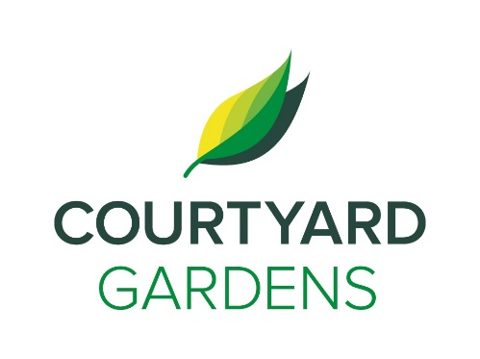

ourtyard

onnection

C

Assisted Living

October 2020

Monday, October 7th

**BC General Election**

Voting will be different this year!

Residents will receive a mail in ballot from Elections BC.

There will be a designated resident trained by Elections BC to instruct you on how to complete and mail in your ballot.

More information will be coming soon!

**A Few Words from Our General Manager, Amanda**

Every October we celebrate Thanksgiving.

I am thankful for some different things this year.

They are:

**T**- The tremendous commitment made by all our staff during challenging times

**H**- Having a great team to work with every day

**A**- Adversity, it makes us stronger

**N**- New ways to do things we have not faced before with creativity and flexibility

**K**- Keeping Calm

**S**- Smiling faces of all the staff and residents behind their masks!

I am thankful for the health of my family and that they are all safe. I am thankful for the staff and that they continue to do the most important and essential work each day. I am thankful for all of you for choosing to live here and trusting us to do what is needed.

Happy Thanksgiving!

**A Warm Welcome to the Following Residents:**

Nan Chang (#107)

Louise Lennea (#202)

Shirley Bakaway (#217)

John Dougans (#320)

Esther Morisse (#332)

**Gardenside welcomes** Arthur Gaudry (#15)

****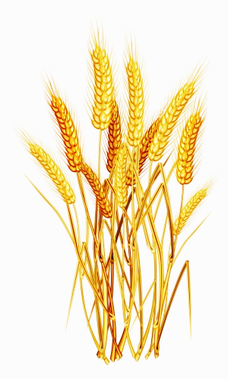

**Two scary staff members will be delivering treats**

**on Friday, October 30th.**

**You must**

**complete**

**The “Trick”**

We will be serving a traditional thanksgiving

dinner in the dining room on

Sunday, October 11th and Monday, October 12th!

LIVING, LOVING, LOCAL

Join us, as we celebrate our

love for local **Corn,**

throughout the month of

October.

DINING DELIGHTS AT CYG

**FEATURED LIFE ENRICHMENT EVENTS IN OCTOBER**

* **Brian Zalo Performing in the Courtyard or on the TV via “Zoom”** – Friday, October 2nd at 3:00 PM
* **Octoberfest Happy Hour in the Dogwood Room** – Tuesday, October 6th at 2:30 PM & 3:30 PM
* **Travelogue Video of Germany in the Dogwood Room** – Wednesday, October 7th at 2:00 PM
* **Music Time with Haley Performing in the Dogwood Room** – Friday, October 9th at 3:00 PM & 4:00PM
* **Thanksgiving**!
* **Music Time with Linda in the Dogwood Room** – Friday, October 16th at 3:30 PM
* **October Birthday & Welcome Tea (by invitation only)** – Monday, October 19th at 3:30 PM
* **Travelogue Video of The Olympic National Park in Olympic Peninsula, Washington** – Wednesday, October 21st at 3:30 PM
* **Brian Gimbel Performing in the Courtyard** – Friday, October 23rd at 3:00 PM