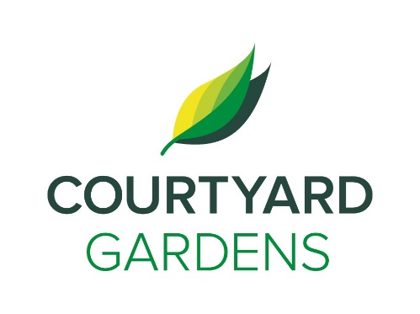

ourtyard

onnection

C

Assisted Living

November 2020

Monday, October 7th

**A Message from Amanda**

In order to continue to keep everyone as safe as possible, we are asking all residents wear masks in any common areas outside of your suite. This means in hallways, in programs, in the elevator and while waiting to go in the dining room. Of course, you can take your mask off while you eat and please no visiting residents in the hallways, common areas or in suites.

We are in the second wave and so we may see restrictions increase again.

Please make sure you are washing your hands often, keeping your distance from others and keeping your contact with family very limited.

If you have a loved one at another care home, please limit your visits. If you have recently visited a home that has COVID-19, we are asking you to isolate in your suite for 14 days as a precaution.

The best advice is from Dr Bonnie Henry, be safe, be calm and be kind. Wear your mask, wash your hands.

We are all doing this together to keep everyone safe.

**Remembrance Day**

Remembrance Day is coming up on November 11th. Join us in the Dogwood room at 10:45 AM for a Remembrance Day service and at

2:00 PM for a special Remembrance Day program honoring our veterans. Thank you to all who have served and fought for our country.

**A Warm Welcome to the Following Residents:**

Margaret McDermid (#212)

Cindy Seaman

(#327)

**Gardenside Welcomes:**

Nishi Hitoshi

(#29)

Jean Nolan

(#30)

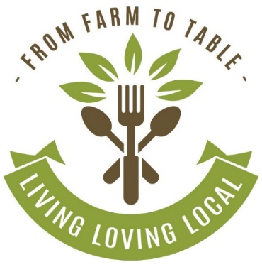 0

Charlene is on leave for 2 months! All Life Enrichment staff can fill in where needed. We look forward to her return in January.

* **Movie Night is Back!** – Every Tuesday Evening at 6:30 PM
* **Music Works with Lorri** –Wednesdays at 1:00 PM
* **Jennifer Lauren Performing in the Dogwood Room via “Zoom”** – Friday, November 6th at 3:30 PM
* **Remembrance Day TV Service in the Dogwood Room** – Wednesday, November 11th at 10:45 AM
* **Peter Montgomery Performing in the Dogwood Room via “Zoom”** – Friday, November 13th at 3:30 PM
* **Hot Chocolate To-Go!** – Pick Up in the Fireside Lounge Saturday November 14th at 3:30 PM
* **November Birthday & Welcome Tea (by invitation only)** – Monday, November 16th at 2:30 PM
* **Kurt von Hahn Performing in the Dogwood Room via “Zoom”** – Friday, November 20th at 3:30 PM
* **Jennifer Lauren Performing in the Dogwood Room via “Zoom”** – Friday, November 27th at 3:30 PM

**LIVING, LOVING, LOCAL**

Join us as we celebrate our

love for local

**West Coast Salmon**

throughout the month of

November.

**FEATURED LIFE ENRICHMENT EVENTS IN NOVEMBER**