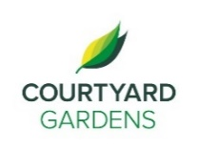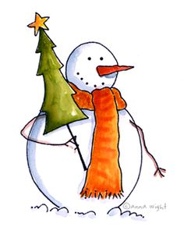

C

ourtyard

onnection



December 2020

Assisted Living

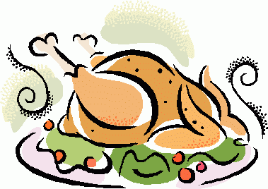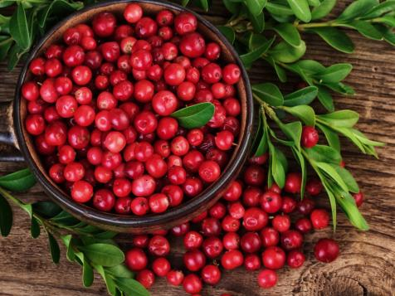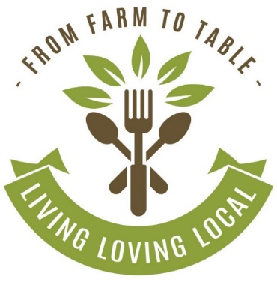

**Christmas Day**

**A traditional Christmas dinner will be served!**

* **3rd Floor Festive Warm Drink Deliveries! -** Wednesday, December 2nd at 2:30 PM
* **2nd Floor Festive Warm Drink Deliveries!**  **-** Monday, December 7th at 2:00 PM
* **Brian Zalo Virtual Performance -** Friday, December 4th at 3:30 PM
* **Jennifer Lauren Virtual Performance -** Wednesday, December 9th at 3:30 PM
* **Allen Boolinoff Virtual Performance -** Friday, December 11th at 3:30 PM
* **December Birthday & Welcome Tea (by invitation) -** Monday, December 14th at 2:30 PM
* **Egg Nog Social: Door to Door Service! -** Wednesday, December 16th at 2:30 PM
* **Fakaro Family Carolers Performing Outside -** Thursday, December 17th at 7:00 PM
* **Caminando Carolers Performing Outside -** Friday, December 18th at 2:30 PM
* **Visit from Santa -** Thursday, December 18th at 3:30 PM
* **3rd Floor Festive Warm Drink Deliveries! -** Monday, December 28th at 2:00 PM
* **New Year’s Eve Party Cart! -** Thursday, December 31st from 2:00 - 4:00 PM

**New Year’s Eve**

**Enjoy champagne with your dinner to help ring in the New Year!**

**FEATURED LIFE ENRICHMENT EVENTS IN DECEMBER**

Join us as we celebrate our

love for local

**Cranberries**

throughout the month of

December

Until further notice due to COVID-19 guidelines,

**Exercises** will remain cancelled to help us stay safe & healthy.

For those who attended **Happy Hour**, it will now be delivered to your rooms.

**A Warm Welcome to the Following Resident:**

Ruby Hau

#312

**A Fond Farewell to the Following Residents:**

Evgenia Beinart #102

Lois Farrell

#121

Sylvia Owins

#215

Eileen Robertson

# 230

**LIVING, LOVING, LOCAL**