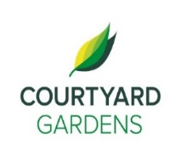

ourtyard

**C**

onnection

February 2021

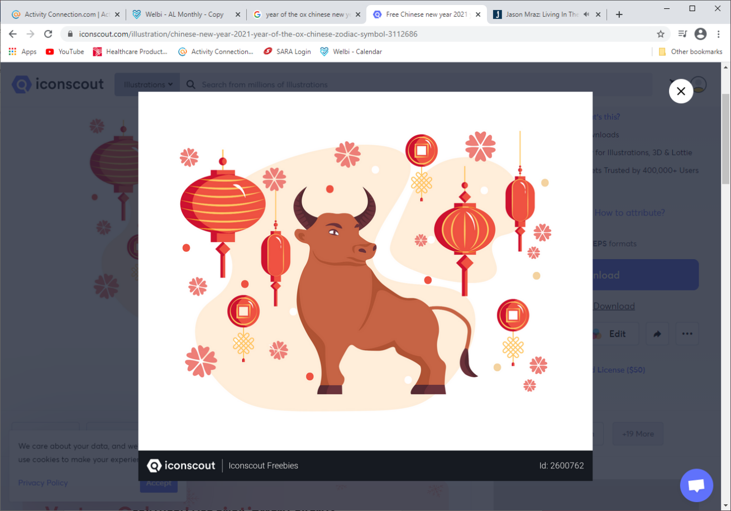

Assisted Living

**Happy Lunar New Year!**

**2021 is the Year of the Ox**

**Gung Hay Fat Choy** is how Cantonese speakers wish you a happy new year—literally "wishing you great happiness and prosperity”.

**Why is red the official color of Chinese New Year?**

**“Legend has it that it all began with the Nian, a ferocious beast that would terrorize villagers on the New Year, eating crops, livestock, and even children. But villagers learned that this half bull with a lion head was afraid of three things: fire, noise, and the color red. Nian was defeated, and from then on, the color red was considered to bring good luck and good fortune to all.”**

**Fun Fact**: red envelopes containing money are often given from elders to children or unwed young adults. By giving the money to children, elders are hoping to pass on a year of good fortune and blessings. Another version is given by the younger generation to their elders as a blessing of longevity and a show of gratitude.



**A Warm Welcome to**

**Lyn Bryant in**

**suite 334**

**Happy 100th Birthday to Annie Dublanica!**

**LIVING, LOVING, LOCAL**

Join us as we celebrate us

love for local

**Beef**

throughout the month of February

**FEATURED LIFE ENRICHMENT EVENTS**

**Due to COVID-19 all activities are limited to 5 participants at this time**

* **Roving Reporter / Linda -** February 1st and February 22nd
* **Technology Works – February 3,9 and 16th**
* **Music Works with Lorri -** Wednesdays at 1:30 pm
* **February Birthday and Welcome Tea -** Monday, February 8that 2:00
* **Lunar New Year -** Friday, February 12th
* **Lunar New Year Raffle –** Guess how many gold coins in the Jar
* **Valentine’s Day Virtual Concert -** February 14th 2:00 and 3:30pm
* **Hot Chocolate and Heart Cookies -** Room Service in afternoon
* **Mike Kinal Virtual Concert –** Friday, February 12th at 3:30pm
* **Kurt von Hahn Virtual Concert –** Friday, February 19th at 3:30 pm
* **Pink Shirt Day -** Wednesday, February 24th
* **Peter Williams Virtual Concert-** Friday, February 26th at 3:30 pm