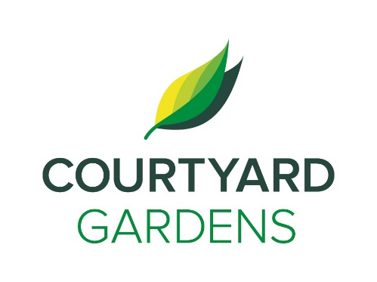

**C**

ourtyard

onnection

Courtyarddd

March 2021

Assisted Living

****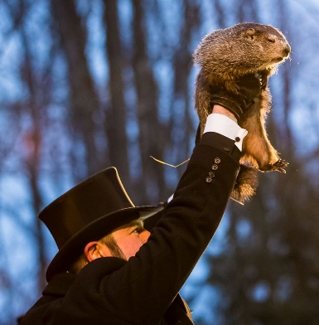

**Daylight Savings Time is Here**

Daylight Savings begins at 2:00 am on **Sunday March 14th.** Don’t forget to change your clocks and enjoy an extra hour of sunshine!

St. Patrick’s Day is celebrated annually on March 17th in honor of Saint Patrick. Please **join us** in celebrating by **travelling to the undiscovered vistas of Ireland at 2:00 pm and an Irish coffee social at 3:00 pm** in the Dogwood room.

Did you know **leprechauns are the reason your supposed to wear green** on St. Patrick’s Day? The tradition tied to folklore says that wearing green makes you invisible to leprechauns who like to pinch anyone they see. **So,** **wear green or risk getting pinched!**

**Spring is**

**Almost**

**Here!**

With the official start of Spring being **March 20th,** nicer weather is just around the corner. Perhaps sooner than expected as Ontario’s Wiarton Willie says he did not see his shadow on [Groundhog Day](https://globalnews.ca/tag/groundhog-day/) and has **predicted an early spring for 2021.**

As the weather starts to get warmer we will be starting to take the trio bike back out for rides! **If you are intrested in going out on the bike please let Charlene or one of the life enrichement staff know.**

**LIVING, LOVING, LOCAL**

Join us as we celebrate our

love for local

**Maple Syrup**

throughout the month of March

**FEATURED LIFE ENRICHMENT EVENTS**

**IN MARCH**

* **Chair yoga will now be offered 2 days a week!** - Tuesdays and Sundays at 10:00 am
* **Are you Irish? Talk with the Roving Reporter –** March 3rd and 15th at 2:00 pm
* **Martin Adock Virtual Performance** - Friday March 5th at 3:30 pm
* **Let’s Celebrate being Fully Vaccinated with a Vaccination Vacation Happy Hour** - Tuesday March 9th at 2:30 & 3:30 pm
* **MOMA Discussion Group** - Wednesday March 10th at 2pm
* **St. Patrick’s Virtual Concert** – Friday March 16th at 2:30 & 3:30 pm
* **Undiscovered Vistas** **of Ireland Film-**Wednesday, March 17th at 2:00 pm
* **Robberto Risman Virtual Performance -** Friday March 19th at 3:30 pm
* **March Birthday & Welcome Tea** - Monday March 22nd at 2:00 pm
* **Celtic Fiddler Virtual performance** - Friday March 26th at 3:30 pm