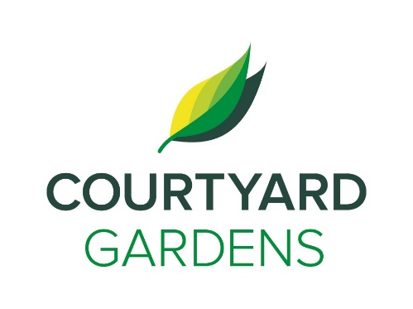

C

ourtyard

onnection

April 2021

Assisted Living



Easter is a **Christian holiday** commemorating the resurrection of Jesus from the dead and will be **celebrated on April 4th** this year.

**Have you ever wondered why Easter is not always in April?** The holiday falls on the first Sunday after the first full moon after the spring equinox.

**The Bus is Back!**

We are excited to announce that we are finally able to use the bus again. **Hooray!** The bus is scheduled to go out for **scenic drives** throughout the month of April with **dates still being finalized.** We are looking forward to getting out again!

**Springtime is for Trio**

**Bike Rides!**

As you may have seen the **Trio Bike is back**! As the weather continues to get warmer we will be taking the bike out for rides more often. **If you are intrested in going out on the bike please let Charlene or one of the life enrichement staff know.**

**April Fool’s Day**

April Fool's Day is an **annual custom on April 1st consisting of practical jokes and hoaxes**. Jokesters often expose their actions by **shouting "April Fools!"** at the recipient. April Fool’s day **ends at 12 noon so make sure to play a friendly joke on someone before then!**

* **Toonies For Tummies –** April 1st - 22nd
* **Join us for an Afternoon of Song –** Friday April 2nd at 3:30 pm
* **Music works with Lorri –** Wednesday April 7th and 21st at 1:30 pm
* **Meet the new staff of Courtyard Gardens with the Roving Reporter -** April 27th at 10:00 am
* **Brian Zalo Virtual Concert –** Friday April 9th at 3:30 pm
* **Meet me at MoMa Lecture –** Wednesday April 14th at 2:00 pm
* **Artful Aging Week–** March 25th -30th
* **Jennifer Lauren Virtual Concert –** Friday April 23rd at 3:30 pm
* **April Birthday and Welcome Tea –** Monday April 26th at 3:30 pm

**LIVING, LOVING, LOCAL**

Join us as we celebrate our

love for local

**Eggs**

throughout the month of April

**FEATURED LIFE ENRICHMENT EVENTS**

**IN APRIL**