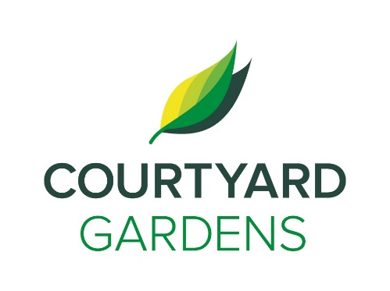

ourtyard dd

C

onnection

May 2021

Assisted Living

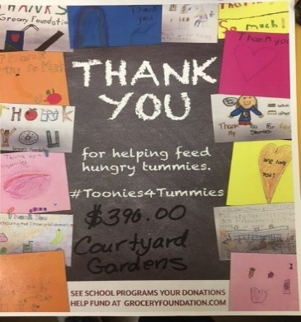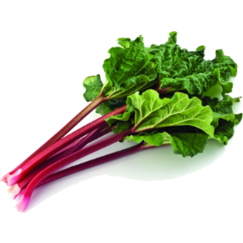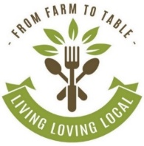

**A Few Words from Amanda,**

The changes have been challenging but we are

committed to doing our best to meet the needs of all

residents while following the health and safety requirements set by

Vancouver Coastal Health. Please wear a mask, wash your hands frequently, stay in if you do not feel well and avoid any gatherings when out with family.

Mother’s Day is coming up and I want to wish a Happy Mother’s Day to all our residents and staff who are moms! Thank you to all the moms! We would not be here without you!

Program Changes:

* Happy hour is moved back to **Fridays at 3:30 p.m.**
* Trivia is moved to **Tuesdays at 3:00 p.m.**

**Toonies for Tummies Fundraiser**

100% of your donation will benefit the growing number of hungry children and it’s never been more vital. Before Covid-19, many Canadian children (1 in 5) were at risk of food insecurity and trying to learn while hungry. A growing number, some estimate

twice as many, may be at risk.

**We raised a total of $390!**

**Thank you to everyone who**

**contributed!**

**LIVING, LOVING, LOCAL**

Join us as we celebrate our love for

**Rhubarb**

throughout the month of May

Resident Forum will return on

Thursday, May 6th at 10:30 am

In the Dogwood Room

* – **Wednesday, May 5th**
* Mother’s Day Delivery of Gifts – **Sunday, May 9th 2:00 p.m.**
* May Birthday & Welcome Tea - **Tuesday, May 11th 2:30 p.m.**
* New Game: Family Feud – **Wednesday, May 12th 2:00 p.m.**
* Music Variations Virtual Concert - **Friday, May 14th 2:30 p.m.**
* Peter Williams Virtual Concert - **Friday, May 28th 2:30 p.m.**

**FEATURED LIFE ENRICHMENT EVENTS MAY**

