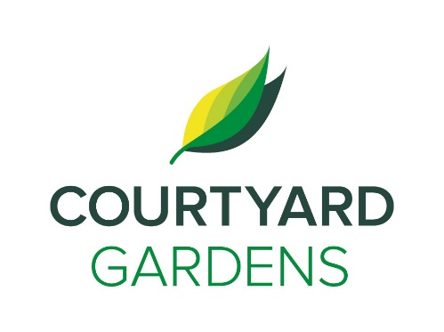

ourtyard dd

C

onnection

June 2021

Assisted Living





**Window Cleaning**

Please have your windows closed Monday, May 31st, Tuesday June 1st, and Wednesday June 2nd for window cleaning!

* Shopping Bus to Ironwood Plaza – **Thursday, June 3rd at 1:30pm**
* Live Music with Martin Adcock – **Friday, June 4th at 2:00pm**
* Food Forum – **Thursday, June 10th at 10:30am**
* Trio Bike Taxi Rides – **Thursday, June 10th at 1:30pm**
* Live Music with Brian Zallo – **Friday, June 11th at 2:00pm**
* Birthday & Welcome Gathering – **Monday, June 14th at 2:30pm**
* Live Music with Allen Boolinoff – **Friday,** **June 18th at 2:00pm**
* Father’s Day Social Lunch – **Sunday, June 20th at 12:00pm**
* Ice Cream Truck – **Sunday, June 20th at 2:00pm**
* Making Strawberry Jam – **Monday, June 21st at 1:30pm**
* Shopping Bus to Ironwood Plaza – **Thursday, June 24th at 1:30pm**
* Weekend Bingo – **Saturday, June 26th at 2:00pm**
* Decorating for Canada Day – **Monday, June 28th at 2:00pm**

**First Day of Summer**

This year, the June solstice occurs on Sunday, June 20th, marking the start of summer. It is the longest day of the year! Remember to wear sunscreen, sun hats and glasses!

**A Few Updates at Courtyard Gardens,**

June will be a busy month at Courtyard Gardens for us as we welcome a new member to our Life Enrichment Team, Mona Xiao!

We also celebrate the return of the Shopping Bus, the Trio Bike Rides and our Ice Cream Socials!

 



Ice Cream Truck on June 20th for Father’s Day 2-3pm

**Food Forum**

Food Forum will return on Thursday, June 10th at 10:30am. Lorne and Amanda will be hosting!



**Some Kind Words from Amanda,**

We are looking forward to better days ahead, thank you for your continued compliance and patience! Please remember to use a tissue, cover your mouth and nose if you are coughing or sneezing, wash your hands often and stay home if you are unwell. Wearing a mask is still a good idea.

Thank you, Linda, for your smiles, antics, and kindness over the years to all the residents and staff at Courtyard Gardens. We will miss you!

On June 9th we are celebrating our staff with some much-deserved service awards. Congratulations to these great staff members:

Allison at 10 years

Wendy, Gloria, Gabi, and Voula all at 15 years

Nerissa at 25 years

Pam B, Geeta, Yolanda, Diane, Shila and Yvette all celebrating 30 years!

**FEATURED LIFE ENRICHMENT EVENTS MAY**

Join us as we celebrate our love for

**Strawberries**

throughout the month of May

**LIVING, LOVING, LOCAL**

