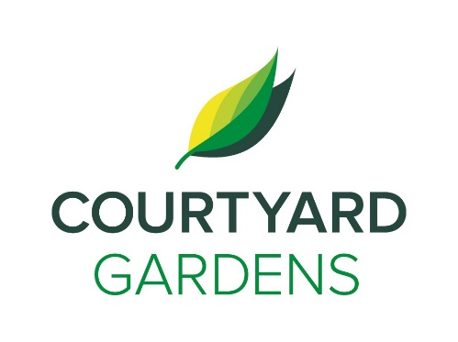

courtyardd dd

C

onnection

July 2021

Assisted Living



**Tokyo Olympics**

**Starting, Friday July 23rd**

**Check your Daily Activity sheet for lots of fun events.**

**Amplifon**

**Hearing Consultants**

**Returning on**

**Tuesday, July 6th @**

**3:00 PM**

**Carnation Room**

**By appt.**

**Wednesday, July 7th**

**International Chocolate Day!**

Attend any Program and claim a chocolate bar as your reward!!

**Celebrate**

**Living Loving Local**

**Peaches**



* Canadian Trivia - **Thursday, July 1st at 10:30am**
* Canada Day Celebration – **Thursday, July 1st at 2:00pm**
* Ice cream social in the courtyard – **July 1st at 3:00pm**
* Bananagrams – **Sunday, July 4th at 1:30pm**
* Helping Hands w/ Charlene – **Monday, July 5th at 2:00pm**
* Brian Zalo Entertainment Hour – **Wednesday, July 7th at 3:30pm**
* String Quartet performance – **Friday, July 9th at 2:00pm**
* Scenic Drive – **Saturday July 11th at 2:00pm**
* July Birthday & Welcome Tea-**July 13th at 2:30 pm**
* Helping hands w/ Charlene – **Monday, July 19th at 2:00pm**
* Shopping Bus to Blundell Centre – **Thursday, July 22n 9:30am**
* Parade of Nations Walk- Residents carrying Flags of their home
* countries – **Friday, July 23rd at 2:00 pm**
* Entertainment Hour w/ “Paramount “-**Friday, July 30th at 2:00pm**

**Some Kind Words from Amanda,**

Stay cool, drink water and avoid going outside during the warmest part of the 12noon-4pm. There is water available by the elevator, at each meal and in the Carnation Room if you have a bottle to fill up.

With summer comes staff time off, and a few maternity leaves too. You will notice some of the team away on vacation and taking a much-needed rest. Please be kind

We are looking forward to the upcoming Tokyo Summer Olympics and we will be doing some fun Olympic activities around Courtyard, starting, July 23rd.

The patio garden looks great with a big Thank you to Al Watt and his family for doing the hard work of planting all the beautiful flowers and keeping them watered. It looks wonderful. Spring cleaning is rolling along, please be patient as the heat has slowed us down some. If you are watering your plants on your balcony, check below for neighbors first.

**Canada Day Celebration at Courtyard**

Start the morning with Canadian Trivia Challenge, Prizes will be awarded. Relax in the Courtyard and listen to Shadows from the

Past, Music Duo and then top that off with. Maple Flavored Ice Cream Bars



Extreme Heat warning!

remember to drink water, stay hydrated and stay cool!

**FEATURED LIFE ENRICHMENT EVENTS JULY 2021**

