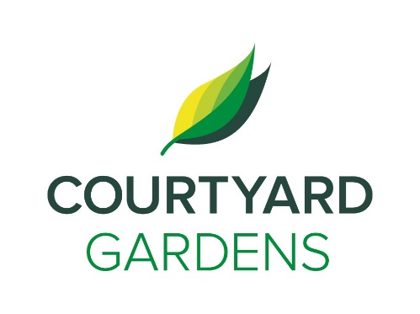

ourtyard dd

C

onnection

August 2021

Assisted Living





**Lunch Outing:**

Sign up at Reception for our lunch outing to Bridgeport Whitespot on August 17th

Residents to pay for their own meals.

**Important News:**

Some Volunteers

will return in August,

Welcome Back

Margaret and Gwen!!



**Christmas in the Summer on August 27th!!**

Christmas in Hawaii Entertainment Hour w/ Peter Williams at 2:00pm

Hawaiian Christmas Dinner at 4:45pm

**Some Kind Words from Amanda,**

We are heading back to warmer temperatures so please be mindful in the next coming days and weeks. Make sure you have a fan, you are staying hydrated, and avoiding the warm parts of the day in the sun. Keep the blinds closed on your windows and make sure the windows are open and the heat is off.

The Dogwood Room has air conditioning and you are welcome to come cool down there anytime.

Heading into August, we felt that we missed celebrating December as per usual with all our festive events, so we are planning to do a Tropical Christmas in August! Check the calendar for details. We would also like to celebrate by sharing some of our good fortune, living and working here at Courtyard with those less fortunate by collecting cash donations for the Red Cross to be given to the Lytton fire victims. Please consider a small donation if you can, we will set up a drop box for the month of August at reception.

The dining room is a space for all to use, please be kind and respectful to everyone. Sit with new people, meet new friends, and enjoy meals together.

**LIVING, LOVING, LOCAL**

Join us as we celebrate our love for

BLUEBERRIES

Throughout the month of August



* Knit, Stitch & Visit – **August 2nd at 2:00pm**
* Scenic Drive – **August 3rd at 2:00pm**
* Shopping bus to Ironwood Plaza – **August 5th at 1:30pm**
* Card Games with Mona – **August 7th at 2:00pm**
* Knit, Stitch & Visit – **August 9th at 2:00pm**
* Artworks with Allison – **August 11th at 2:00pm**
* Shopping bus to Ironwood Plaza – **August 12th at 1:30pm**
* Pacific Chamber Music Academy – **August 13th at 2:00pm**
* Ladder Ball – **August 14th at 3:00pm**
* Knitch, Stitch & Visit – **August 16th at 2:00pm**
* Life Stories with Linda – **August 16th at 2:00pm**
* Lunch Outing to Whitespot – **August 17th at 11:30am**
* Meet me at the MoMa – **August 18th at 2:00pm**
* Jennifer Lauren Performance – **August 20th at 2:00pm**
* Young Musicians and Artists Performing – **August 21st at 3:00pm**
* Knit, Stitch & Visit – **August 23rd at 2:00pm**
* August Birthday Welcome and Tea – **August 24th at 2:30pm**
* Christmas in Summer – **August 27th**

**FEATURED LIFE ENRICHMENT EVENTS AUGUST 2021**

