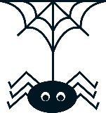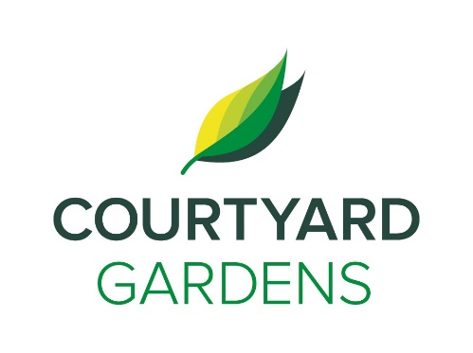

onnection

ourtyard

October 2021

Assisted Living

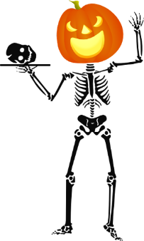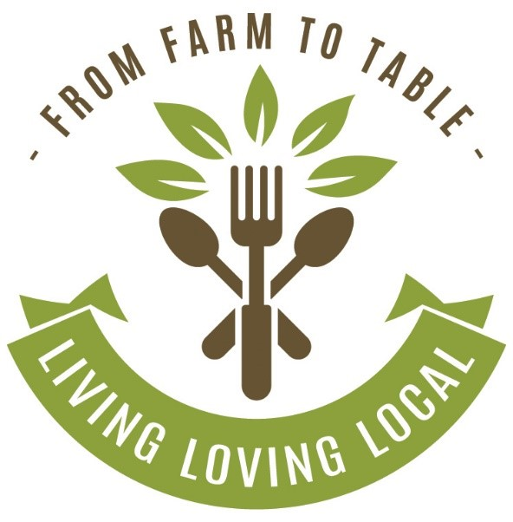

**Pumpkin Spice Latte Social**: Tuesday, October 19th at 3:00 p.m.

**Pumpkin Painting Project**: Tuesday, October 26th & Thursday, October 28th at 2:00 p.m.

**Dress Up Day**: Wear your Best Costume or borrow from Charlene's Tickle Trunk - Friday, October 29th

**Halloween Bingo**: Saturday, October 30th at 2:00 p.m.

**Hot Apple Cider Social**: Saturday, October 30th at 3:30 p.m.

Entertainment Hour

Bring 3 of your favourite old vinyl records for us to play

Dogwood Room

Friday, October 1st

2:00 p.m.

Happy International Seniors Day!

On October 1st, we will celebrate the contributions of seniors in our homes, communities, and workplaces

*We invite you to visit and attend any of our featured dining events with friends and family.*

*Stay for a meal in our private dining room!*

***Make a reservation anytime!***

***604-273-1225***

**Lutheran & Catholic In-house Services will start this month!**

Please check the

calendar for more details

**FEATURED LIFE ENRICHMENT EVENTS IN OCTOBER**

* **International Day of Older Persons** - **Friday, October 1st**
* Entertainment Hour (bring your records!) - **Friday, October 1st 2:00 p.m.**
* Introduction to Nordic Walking Poles w/ Charlene - **Monday, October 4th 1:30 p.m.**
* Scenic Drive (sign up at reception) – **Tuesday, October 5th 2:00 p.m.**
* Entertainment Hour w/ Vonda Sinclair - **Friday, October 8th 2:00 p.m.**
* Lutheran Church Service (in person) – **Sunday, October 10th 2:00 p.m.**
* October Birthday & Welcome Tea – **Tuesday, October 12th 2:30 p.m.**
* Entertainment Hour w/ Patricia Coletta – **Friday, October 22nd 2:00 p.m.**
* Lunch Outing to Legend’s Pub (sign up at reception) – **Thursday, October 28th 11:30 a.m.**
* Entertainment Hour w/ Peter Williams **– Friday, October 29th 2:00 p.m.**
* **Happy Halloween! – Sunday, October 31st**

**Halloween Events**

Join us, as we highlight & feature

our love for apples this month!

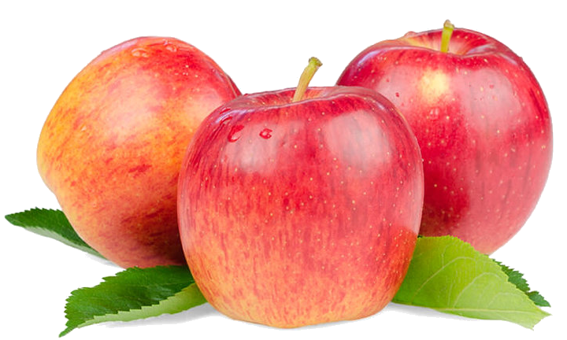

**New Program!**

**Introduction to Nordic Walking Poles w/ Charlene**

**Monday, October 4th 1:30 p.m.**

DINING DELIGHTS AT CYG