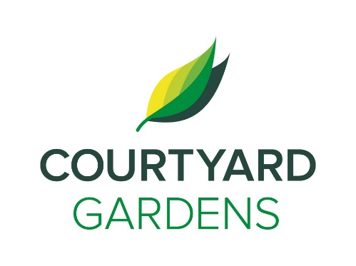

ourtyard

onnection

Assisted Living September 2021

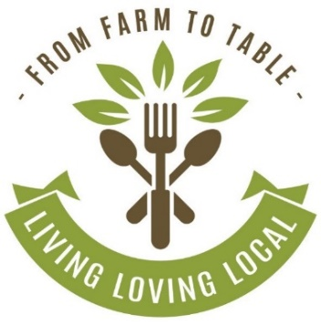

**Voting Station - Federal Election**

Monday, September 13th

9 a.m. – 12 p.m.

Dogwood room

**Lunch Outing to The Milltown Pub**

**September 28th**

Sign up at the reception desk!

The bus departs at 11:30 a.m. and all

residents pay for their own meals

Mid-Autumn Festival Tea Social

Learn about this special occasion in the Asian Culture and sample delicious moon cakes!

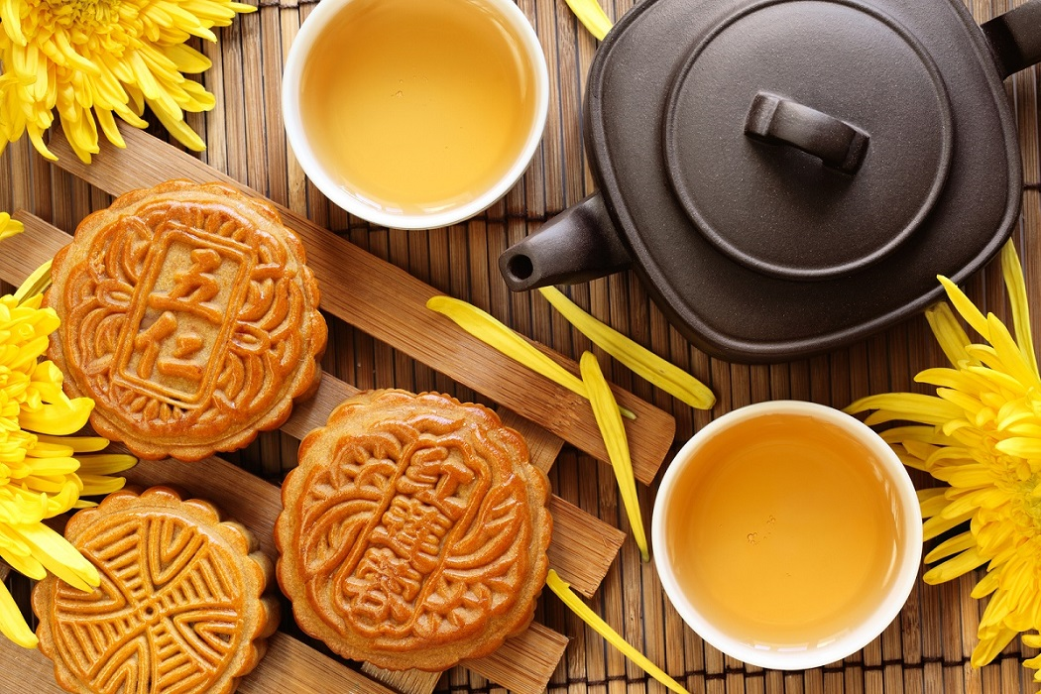

Hosted by Mona!

September 20th at 2:00 p.m.

Dogwood Room

**A few words from our GM, Amanda**

We are having a planned power outage on Tuesday, September 7th. It will be

about 3 hours from 12 – 3 p.m.

We will be modifying our lunch

service. All elevators, tv’s etc will

not be able to be used. If you wish, please make alternate arrangements to be out during the day, otherwise, we will be supporting all residents in suite for the duration of the outage. This is in preparation for our generator installation.

This is a good reminder for all residents to check your emergency preparedness supplies.

Do you have a working flashlight?

Do you have a copy of your medications?

Do you have water and some snacks ready to go, a sweater, and a pair of shoes if we need to evacuate the building?

Plan ahead for these times and we can use the power outage as a practice situation.

*We invite you to visit and attend any of our featured dining events with friends and family.*

*Stay for a meal in our private dining room!*

***Make a reservation anytime!***

***604-273-1225***

Join us, as we highlight & feature

our love for pears this month!



DINING DELIGHTS AT CYG

**FEATURED LIFE ENRICHMENT EVENTS IN SEPTEMBER**

* Hands-on Technology Workshop: iPad - **Monday, September 6th at 2:00 p.m.**
* News and Views with Charlene - **Wednesday, September 8th at 11:00 a.m.**
* Scenic Drive – **September 11th & 21st at 2:00pm**
* Shopping Bus
  + **September 2nd, 9th, 23rd at 1:30 p.m.**
  + **September 16th at 9:30 a.m.**
* September Birthday & Welcome Tea - **Tuesday, September 14th at 2:30 p.m.**
* Performance by Music Variations – **Friday, September 17th at 2:00 p.m.**
* Performance by Young Musicians and Artist – **Sunday, September 19th at 3:30 p.m.**
* Lunch Outing to Milltown Pub – **Tuesday, September 28th at 11:30 a.m.**