

**⭘ January | ⭘ 2019**

Granville

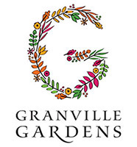

***Meet Granville’s New Team Member***

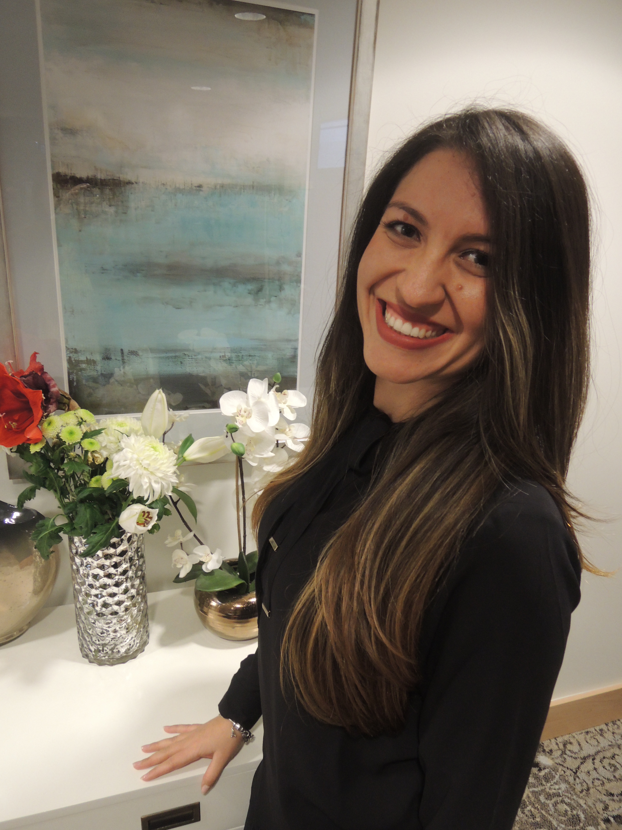

**Pamella Garcia Theobald**

Pamella moved to Canada in August, 2018 from Brazil. She has over ten years of Hospitality Management experience and has an educational background in Marketing, Communication and Business. Pamella is also multilingual. She speaks Portuguese, Spanish, and English.

Her husband Ian is from Canada.

They met while she was studying here

3 years ago. Pamella enjoys fitness activities in her free time. She runs, dances, practices yoga and goes to the gym. She is very excited to explore and gain new experiences here in her new home in Vancouver, and Granville Gardens!

**Vancouver Public Library Accessible Services is coming! If you have signed out any Vancouver Public Library books please return them to Granville Gardens Library before January 14th**

**Thank you very much!**

Granville GardensWellness Fair January 25th 9:30 – 11:30 am

**➢** **Remedy R/X Presentation**

**➢ NexGen Hearing**

**➢ Footcare Information … and more!**

Birthday? Anniversary ? Family Events?

**Granville Gardens has you covered!**

Please speak with our Dinning Services Manager Josh about your catering needs for all of your special occasions!

Open Mic & Music JAM Session

January 24th at 6:30 pm

Bring your own instrument

Everyone is welcome!!!



**FEATURED LIFE ENRICHMENT EVENTS IN NOVEMBER**

* **Granville Island Art Exhibition / Shopping Trip** - Wednesday, January 9th 1:00 pm
* **Guitar Sing-along featuring “ Steve Warner ”** - Monday, January 14th 2:00 pm
* **Tsawwassen Mills Shopping Trip** - Wednesday, January 16th 1:00 pm
* **VanString Youth Orchestra** - Sunday, January 20th 1:00 pm
* **Simple Gifts Choir** - Tuesday, January 22nd 7:00 pm
* **Open Mic & Music JAM session** - Thursday, January 24th 6:30 pm
* **Robbie Burns Music Entertainment featuring “ Suede Dog ”** - Monday, January 28th 2:30 pm
* **Art Program with Sandra** - Wednesday, January 30th 2:00 pm

*Gazette*

To create “Resident-Centric” environment where our seniors are inspired to experience Fulfillment – Whatever that means to them.