Cherry Goat Cheese

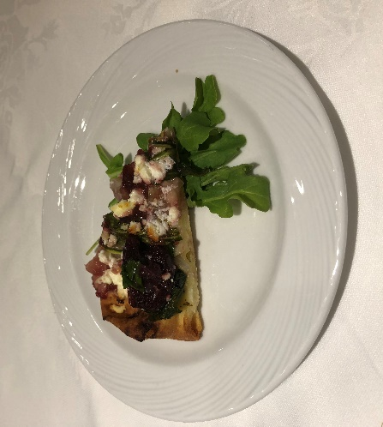
& Arugula Flatbread

Yield: 12 portions

2 Tbsp canola oil
4 cups sliced onions, sliced ¼ inch
½ tsp salt
1 Tbsp extra virgin olive oil
3 flatbread oval 12 x 5 inch
4 cups baby arugula
3 cups fresh LOCAL cherries, pitted, halved
1.5 cups goat cheese
Balsamic glaze for garnish

Preheat skillet over medium heat. Add canola oil and onions. Season with salt.

Cook over medium heat, stirring occasionally, until onions begin to colour. Lower heat slightly, cover, continue to cook, stirring occasionally. Lower heat gradually as onions breakdown and begin to get a richer brown. This will take 45 to 60 min. Onions will develop a rich colour and intense sweet onion flavour.

Remove from heat. Add extra virgin olive oil. Stir through and allow to cool.

To assemble, brush each flatbread with extra virgin olive oil. Spread caramelized onion over bread. Top with arugula, cherries, and goat cheese.

Bake in 350 F oven 5 to 10 min. until goat cheese begins to melt.

Cut each flatbread into 4 portions, drizzle with balsamic glaze and serve.
